Objectives Achieved
- Learned how to nest loops inside each other.
- Practiced generating * patterns using nested loops.
- Understood how break and continue jump statements behave inside loops.
- Implemented number/pattern generation through structured iteration.
Task 1 — Star Pattern Using Nested
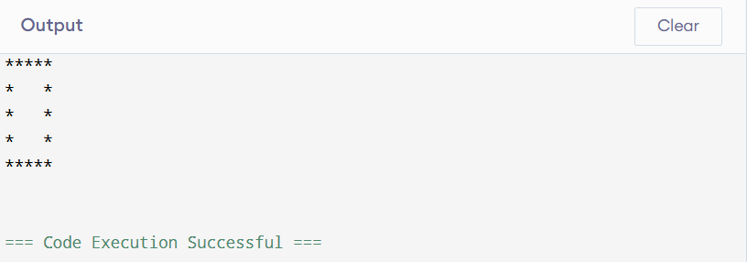
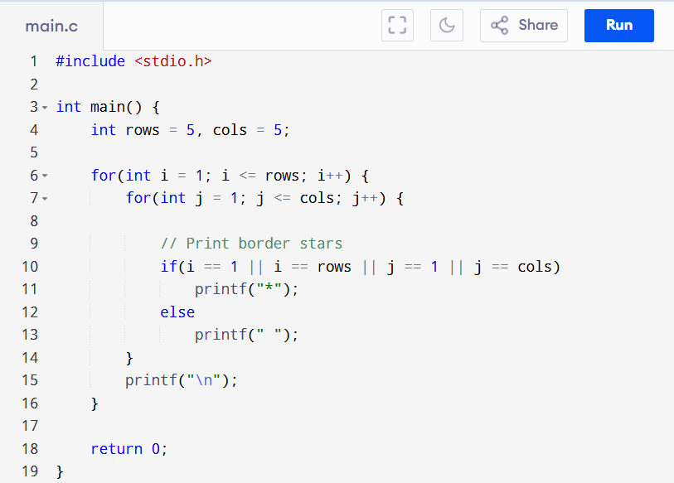
Program code
Conclusion (Task 1)
This task demonstrated how nested loops enable row–column matrix traversal. Logical conditions applied within nested loops make it possible to draw borders and patterns. Using correct loop boundaries was essential for replicating the required hollow rectangle pattern.
Task 2 — Multiplication Table (1 to 10)
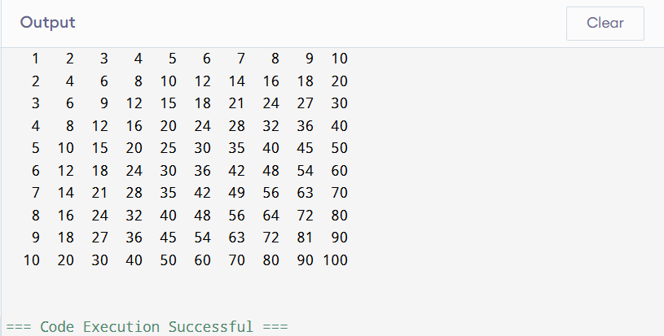
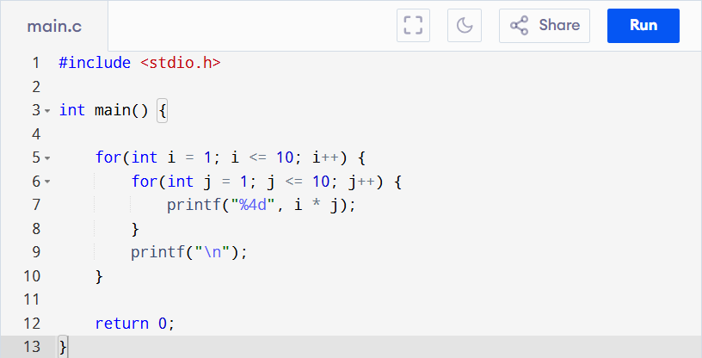
Program code

Conclusion (Task 2)
This task required two nested loops:
- Outer loop for each multiplier (1–10)
- Inner loop for each column product
Post-Lab Task — Sum of a Matrix
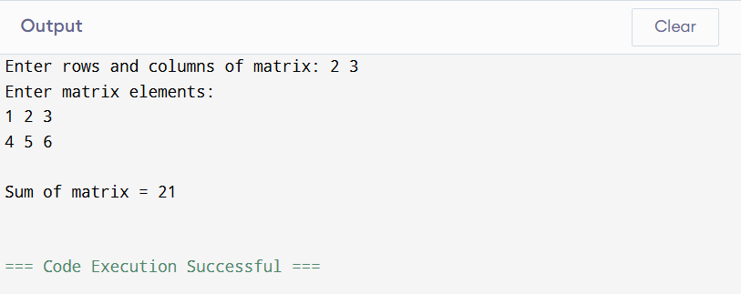
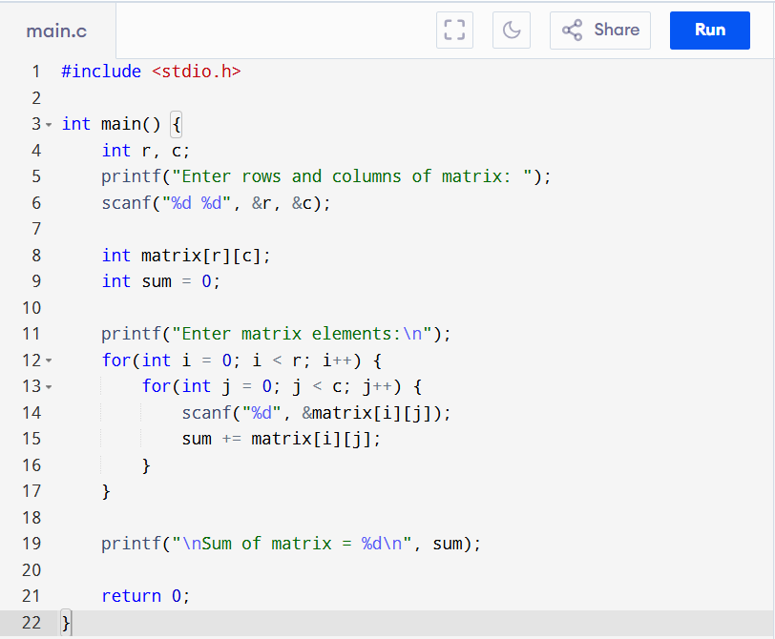
Program code

Conclusion (Post-Lab)
This task reinforced nested loops for multi-dimensional data handling. Summation required iterating each row and column. It also demonstrated user-defined matrix dimensions using variable-length arrays.
Critical Analysis (Lab 5)
This lab helped in deeper understanding of:
- Multi-dimensional iteration
- Nesting logic
- Pattern formation
- Jump statements (continue/break)
The combination of pattern creation and multiplication grids provided foundational experience with nested loops — a key concept for later topics such as matrices, sorting algorithms, and 2D graphics.

